THEORETICAL PROPOSAL FROM SYSTEMS' THINKING FORTHE INTELLIGENT TOURISM SYSTEM

Abraham Briones-Juárez¹, Ricardo Tejeida-Padilla², Erika Cruz-Coria³, Isaías Badillo-Piña ⁴
abrahambriones2003@yahoo.com.mx¹, rtejeidap@ipn.mx², ecoria84@hotmail.com³, ibadillop@gmail.com ⁴
^{1,3} Universidad Autónoma del Estado de Hidalgo, México.
^{2,4} Instituto Politécnico Nacional, México.
^{1,2,3,4} Grupo de Investigación en Sistémica y Turismo GIST

ABSTRACT

Intelligent tourism is difficult to define not only because there are different interpretations according to the researcher focus and the resources target but also because it is a newly topic with difficulty for its practical application. However, lately, some authors have been working on the generation of general elements that characterize this kind of tourism activity, such as the technological utilization, social benefits, sustainability relevance, and products design. This study constitutes a theoretical approach from the systems thinking to analyze the scope of the system of intelligent tourism in order to identify some of the elements and relations through the purpose of a holistic interpretation.

Keywords: Intelligent tourism, system thinking, holistic interpretation.

INTRODUCTION
Getting a definition of tourism has been a very hard task since there are several interpretations of its physical presentations, such as economic results, social changes, sustainable pertinence, and political application. At the same time, these fields are used to study a tourism perspective. In such a case, the disciplines that are related give a theoretical support to study the prominent components. However, Systems thinking provides a scientific language appropriate to study tourism with a holistic approach.
Intelligent tourism is a new concept that conforms the tourism’s fields but focused in technology development. Therefore, It is necessary to make certain efforts to generate a theoretical structure with the possibility of developing and testing hypotheses. This paper presents a set of ideas that support the theoretical development of intelligent tourism through the approach of system thinking in order to get some relevant questions to give some recommendations on methods of approach and a theoretical systemic proposal.

LITERATURE REVIEW

Theoretically, the tourism is based on leisure that is a qualitative concept (Hall and Page 2002) as it takes meaning only inside individual perception. Thus, it has an open and multiple conceptualizations (Lew, Hall & Williams, 2004), for example, leisure definition is based on the perception that people have about on their own trip experience. Therefore, tourism theory is prominently a human issue as the emphasis of its study is focus on social relations, but with technical and mechanical elements that give sense to the human’s objectives.
There are some social sciences that are closely linking to tourism, for instance, sociology (Winter, 1999) anthropology (McGinnis, 2011), economy (Candela and Figini, 2012), and psychology (Šimkova, 2014) policy (Su, and Teo, 2008). Although these sciences have made outstanding advances in tourism definition, they are not enough to cover the concepts as a whole. In fact, in tourism, there is a lack of structural definition, which has generated a certain difficulty to integrating applications and theoretical advancements. Tourism, as a discipline of knowledge, does not have a common language (McKercher, 2016). According to Ateljevic, et at (2011), this field has many ontological, epistemological and methodological shortcomings. Nevertheless, it has multiple concepts that include actors, means, elements, and relations. These factors have been studied in the field of System Thinking (Jafari, 2005), so that system perspective is a means to deal with interdisciplinary topics like tourism (Farrrel & Twining, 2004).

Cybernetics of Systems “In tourism, the internal relations of the system are directed at achieving a common goal, while they are related to its environment, which sets a series of exchanges.
Molina (1996)

Systems analysis and synthesis “Tourism consists of three perspectives: a) a model offer-demand b) a social anthropological approach, c) the industrial tourism model"
Boullon (1985)

Typological definition of systems
"Tourism consists of five elements: a dynamic element (tourists), three geographical elements (the generating region, transit route, and destination region) and one economic element". Leiper (1979)

Teleology of systems
“Tourism is a definable set of relationships, services, and facilities that interact cooperatively”, Cuervo (1967)

Figure 1. Theoretical system definitions
Source: own development

The Systemic Thinking in tourism theory tries both to address the complexity of the phenomenon and to refine its explanation, i.e., tourism prospect is a compound of elements associated with relationships to obtain a common purpose. Figure 1, shows some concepts from systems theoretical approach.

Besides, tourism’s complexity has been studied from different angles e.g., optimization models (Andria et al., 2015; Thulin, 2007; Yu, 2015; Gu, 2003; Parolo et al., 2009) to detect behaviors at both structures deterministic and probabilistic; the soft systems models (Dimmock and Musa, 2015; Espiner and Becken, 2014; Umoh and Ndu 2013; Carlsen, 1999) in order to depicting agreements among the stakeholders that are based on diagnosis or conceptual models; the cybernetic model (Harwood, 2009; Watts, 2009; Gmür et al., 2010; Miaris et al., 2015) to get a logical relationship in agreement with the system purpose; the heuristic methods (Wang, 2004; Lušticky and Bina, 2014; Peng and Lai, 2014; Bloom, 2005) to identify algorithmic patterns; the complex theory ( Baggio, 2014; Baggio and Sainaghi, 2011; Baggio and Sainaghi, 2016; Briones et al., 2011) to characterize systems and their dynamics of balance.
Tourism, in a systemic perspective, tries to find isomorphic ideas. It works with fundamental knowledge to make unification rather than obtain separate results. For that, tourism system perspective has been improved with the new developments as well as new definitions of methods, methodologies, concepts, and constructs with the richness to serve to the different dimensions of tourism theory such as destinations, brands, companies, and sustainability issues. Because systemic thinking is applied in tourism we have new ways to cope with its complexity.

SYSTEMS METHODOLOGY

The system approach proposed by Bertalanffy (1995) refers that systems are analogies inasmuch as laws with identical principles can be applied to different phenomena.
Because a system is endowed with certain properties to achieve its mission (Gigch, 1981), it is able to transform its own form from one internal state to another in consonance with environment variations (Ackoff, 1999). However, this form is defined by several components of the system, essentially its limits (Gigch, 1978), the degree reached in its temporal evolution, and in its purpose. All of these forces have to be aligned with the system efforts. If a system shows an entropic situation, meaning a dysfunctional or static behavior, a homeostatic action should be activated by an internal element to get the equilibrium. The dynamism leads to the new states of the system that are resulting from new conditions, but they are coming from the interaction of system actor’s behavior.
Boulding (1956), proposes a taxonomy of systems, these hierarchies are structured from the next components: the complexity functions, the purposes, the elements and the relations, in his work he includes both non-living and living systems. The last one, incorporate social systems like the most complex to know about. On the other hand, Jackson (1991), proposes that either organizations or society is composed of subsystems; they are involved in several human roles including not only the physical work but also in the planning work. Thus, the social system contains a framework in which efforts can be directed towards the system necessities such as mechanical issues, capability response, or actors understanding.

The system thinkers recognize two specific features present on the structure of a system: a) the governing bodies which are involving in decision-making along with strategy selections and b) the operational structures which are participating in the decisions of routine in terms of the system activity (Barile et al., 2014). The systems approach is a framework that addresses the root causes (Banson et at, 2015), which are applicable to complex organizations and society (Córdoba, 2011) to harmonize both the decision and action. This approach allows us not only to designing and operating technological systems that are built on the development of particular information but also to improving knowledge in an application environment; i.e., a system of business, social, economic or political.
Schwaninger (2015) points out, in tourism the application contexts have been ignored by generating improper concepts; therefore, organizations must be flexible to deal with the emergence (Huang et al., 2011).

INTELLIGENT TOURISM
Intelligent systems depend on the analysis of either internal or external organization’s information, they act as media between stakeholders to giving answers and to learning about the behavior of customers and business strategies (Buyukozkan & Ergun, 2011). Tourism is a domain of application for intelligent systems, due to the complexity of decisions in tourist settings (Gretzel, 2011). The intelligent tourism is center to consumers and suppliers with greater support to enhance the flow of information for the benefit of the users, because they make affordable the knowledge and information in a systematic and efficient way (Del Chiappa, and Baggio, 2015); this efficiently allows the actors to keep linked each other to save both resources and efforts.
New technologies change the consumer behaviors and increase the transparency of the market, besides they facilitate the social commerce to tend to reduce the costs involving (Gretzel et al., 2015). These elements have been studied recently, for example, in the works of Zacarias et al., (2015;) Kiráľová and Pavličeka, (2015); Hussein and Aqel, 2015 and Mendonça et al., (2015). However, in the tourism information technologies have been generated unknown scenarios in companies (Simon et al., 2008) that are coming from the emergence of tourists who are more informed.
Moreover, the management of services is affected by the impact from the sale of services, and the electronic means that creates both opportunities and challenges (Woo et al., 2006). The main changes of services technology are manifested in the variations of performance since they are taking into a count to creating new services and improving others (Kothari et al., 2007). Tourism businesses have faced large changes, because of the revolution in information technology (Yang and Wan, 2004).
Services according to Goo et al., (2008) are determined by the efficiency in the use of technologies, since the information of the customers can be offer and share with other stakeholders while it acts as a key factor of success for the efficiency of the operations; so that it has become a critical source of competitive advantage in the industry (Ham et al., 2005).
Tourism application is developed on complex environments (human systems) that do not act with the logic of the computer design. Nevertheless, Intelligent tourism stand on the idea that actors can increase their knowledge, and this may increase, in the same way, the benefit of organizations, since they uses a database to generate new information that emerges from the everyday social an commercial activities.
Technological design should be tested in the application environment to see if it is necessary to make changes or adjustments to the primary arrangement. Some examples of these technological systems can be seen in the works of Xiang et al., (2015) who were trying to understand the behavior of travelers; on the other hand, Ayscue and Bynum (2016) were focus on the use of various electronic media, which help them to generate information to segment the market, No and Kim, (2015). However, one of the most studied aspects is the performance of companies (Melián and Bulchand, 2016; Shung et al., 2016; Catherine et al., 2016). It is because is more convenient to study systems with previously established purposes as increase yields or economic benefits. However, the technological use by itself not necessarily satisfies the additional components that are present in the definition of intelligent tourism such as sustainability, the saving of resources, and greater satisfaction of tourists, since they usually are focused on some of the aspects or stages of marketing distribution and use of the services.

Social Organization
Thechnological system

Information
Modules
New information

Environment

Figure 2. Actors in intelligent tourism
Source: own elaboration

Intelligent tourism seeks to be a broader concept which links the role of stakeholders while it respects cultural, social, and natural environments of tourism. Thus, we must resort to a holistic vision which allows to overcoming the difficulty of visualize intelligent tourism from a single perspective and with the highest level of methodological and theoretical amplitude.

The purpose of intelligent tourism is not defined previously, but it must be a consensual way construction that can be defined as a system that serves to people’s purpose while the system works both with high efficiently and competitively.

Intelligent tourism has three aspects, attributes, capabilities, and applications (Min, 2015). The first is determined by the connection involved, the second with its degree of expansion or coverage and the third for its capacity of the solution. In this process, information is a key aspect (Owaied et al., 2011). Meaning that we should promote the use of technology without neglecting the human side (Poon, 1998) since only creative and innovative suppliers can respond to new needs (Buhalis, 1998).

THEORETICAL PROPOSAL OF INTELLIGENT TOURISM

To work with intelligent tourism we should be aware of the degree of complexity of the phenomenon. The complexity is understood as the number of elements and relationships that prevail in a system (Luhmann, 1998). In this way, it is possible to make a selection between discipline perspective and the systemic thinking. If the researcher selects the system perspective some steps should be followed to make a good presentation of the system (See figure 3).
Firstly, we have to specify the type of system according to systems taxonomy, if it is a compound system like tourism we can identify the most prominent elements; this help us to determine not only the characteristics and attributes of the system but also to find the means for theoretical treatment.
For instance,
A human system (people involved in the system)
A mechanical system (information involved in the system)
Natural resources (living system to take care of it)

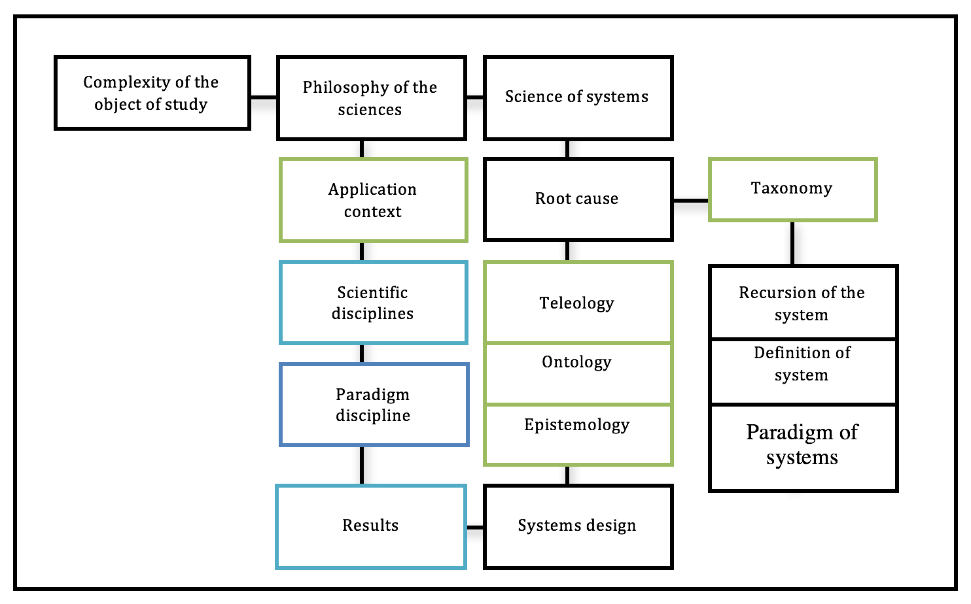
Figure 3. Systemic methodology.
Source: own elaboration.

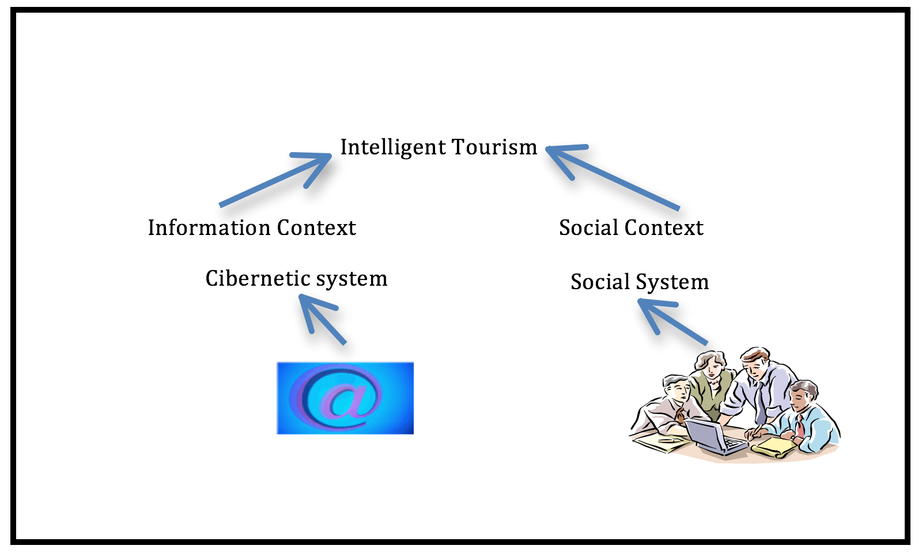
Figure 4. Intelligent tourism contexts
Source: own elaboration.

For information context, we identified the e-turism as part of intelligent tourism. This system is, according to its composition, a social-organizational system. After the definition of important elements, we have to define the theological concept through its purpose, for example, "a system that uses technology to allow the benefits of the actors in a sustainability manner, and with enhancing the visitors experience ". In the case that the purpose is plural as in tourism system the following questions need to be resolved.
Some of the aspects to compound intelligent tourism are more important than others? And if so, what make them more important?
For instance:
Is technology more important than social relation?
Is sustainability less important that technology?

If these questions cannot be resolved it in the first instance, it is necessary to make an internal and external recursion of the system before making the definition, For that, we have to answer the next inquiries: What are the systems in which the system is embodied? And, what kind of subsystems are integrated into them? That will help to get more information about it.

Table 1. Internal and external Recursion of the intelligent tourism.
External recursion | Internal recursion
Government | Benefit of the actors
Technological means | Technological design
Sustainable norms | Elements give it sustainability
Consumer preference | Maximum experience in the visit
Source: own elaboration

These concepts derived from the recursion must be refined since the analysis draws on previous contributions.
To introduce a concept of intelligent tourism, we can use the model of the domain of the science of John Warfield, see (Pacheco and Cruz, 2003) and specify some concepts using the systems' language to present its components and relations, for instance, the recursion levels and the affinity with homeostatic, the negentropic, and the autopoietic mechanisms.
Moreover, we can take into account the value of teleological definition in the sociological context of Burrell and Morgan (1979) to learn about the role of humans in the system, for example, by answering the next interrogations:
Do actors participate in the system's decisions? How many of them take part of the decision-making?
Do actors collaborate in the design and change of the system? How many of them can transform the system?
This knowledge helps to identify if the social system takes part in decisions as well as if it aids in the consensus and the self-regulation, e.g., in a system of intelligent tourism, the company provide with tourist services and it is focused on custom service, and because of that the production's process and elaboration's service requires an unlimited number of decisions. Thus, human's actions work to innovate not only how people use information but also the process to get it. Hence, this system is placed in the paradigm humanistic-interpretive.
This phase in accordance with Jackson, (1991) gives us the location in the contexts problematic, in which the selection of a methodology matches with the definition of the system, that is, its systemic treatment.
In the same way, we can use hard, soft, and critical system approaches (Midgley, 2000) to solve complex problems of intelligent tourism, for example:
If there is a limited action of the stakeholders or if the technological system is more important we can use hard methods (simulation, probabilistic and deterministic methods). Hard approaches including cybernetic and complex theory and they are extended toward the numerical condition and its foundations. Hard Thinking is understood from the point of view of a physical manifestation; i.e. the deductive approach.
If social system is more important than technological definition we can use soft system models to cope with problems, and so on, in agreement to the identification of the important elements and relations.
If we already have a theoretical definition for social and technological system, we need to think about the sustainable part of intelligent tourism.
Because hard and soft systems have a purpose, in this case, to get better information and to use it in better practices respectively. In intelligent tourism we find a mutual aim in order to obtain the better results for people and resources.
For that, we will be use soft systems approach and more particularly Peter Checkland soft systems methodology as it permits to use the ideas of several system thinkers.
The Soft Systems Methodology (SSM) is based on action research where the researcher becomes a participant of the action and the process of change becomes the object of study. In this context, the problem relates to the manifestations of the real world of human activity systems, characterized by a sense of imbalance, that eludes the precise dimension between what is perceived as the reality and perceived that it could be the reality (Checkland, 2001). The logical flow of information requires give a name of relevant systems and that makes a model with the holons in the form of systems of human activity (SAH), to illuminate the problem situation and to structure a debate for change (Checkland, 2001). Systems appointed does not necessarily correspond to parts institutionalized, as they are parts of systems in the real world i.e. versions by what are known as relevant systems based on the dispute (Checkland and Scholes 1994). For more detail of the methodology about the 7 stages that compose it consult Checkland (2001) and Checkland and Scholes (1994).
Soft systems methodology allows us the use of to inductive, abductive and deductive approaches, the first to enrich the dialogue, the second to allow inclusion of the designer expertise and generate hypotheses and the third to measure and validate the assumptions made.
Using this methodology to deal with sustainable idea of intelligent tourism we hope to resolve some of the next questions.

Working with the intelligent tourism through soft system methodology we could wide and resolve some of the next questions:
What is the relationship between the technological design and Government regulations?
What is the relationship between the technological design and the satisfaction of visitors?
How can we improve technological designs while we use the resources in a good manner?
How can we integrate the sustainability and satisfaction of the visitors in the purpose of tourism intelligent to obtain technological and organizational benefits?

Final considerations
The design of the intelligent tourist system should allow the implementation of appropriate control measures. This presentation will address the conjunction of important information, compilation, analysis and presentation of the information technologies for decision-making, by means of instruments that indicate the behavior of the internal actions and their adjustment to external considerations. To increase the information about the State of the system we have to implement actions related to services nature since its creation, integration, and application must consider the stages in which are planned, they present, run, and evaluate services.

CONCLUSIONS

The system of intelligent tourism can be addressed through the science of systems methodology and systemic approach.
This study presents a theoretical approach of intelligent system; there are some recommendations that can support the development of the concept of the system and presents a methodology for its development, also some questions are presented to help with the orientation of the study and soft systems methodology is selected to meet the consensus of those involved.

REFERENCES

Ackoff, R. (1999), Rediseñando el futuro, Editorial Limusa, México.
Andria, J., di Tollo, G. & Pesenti, R. (2015), "Detection of local tourism systems by threshold accepting", Computational Management Science, Vol. 12, No. 4, pp. 559-575.
Ateljevic, I. Morgan, N. And Pritchard, A. (2011), The critical turn in tourism studies; creating an academy of Hope, Routledge, Oxon.
Ayscue, E. and Bynum, B. (2016), “Caitlin E. Mertzlufft, Mobile technology &amp; resident attitude research”, Tourism Management, Vol. 52, pp. 559-562.
Baggio, R. (2014), "Complex tourism systems: a visibility graph approach", Kybernetes, Vol. 43, No. 3/4, pp. 445-461.
Baggio, R. and Sainaghi, R. (2011), "Complex and chaotic tourism systems: towards a quantitative approach", International Journal of Contemporary Hospitality Management, Vol. 23, No. 6, pp. 840-861.
Baggio, R., & Sainaghi, R. (2016). “Mapping time series into networks as a tool to assess the complex dynamics of tourism systems”, Tourism Management, Vol. 54, pp. 23-33.
Banson, K. E., Nguyen, N. C., Bosch, O. J. H., and Nguyen, T. V. (2015). “A systems thinking approach to address the complexity of agribusiness for sustainable development in africa: A case study in ghana”, Systems Research and Behavioral Science, Vol. 32 No. 6, pp. 672-688.
Barile, S., Saviano, M., Iandolo, F., and Calabrese, M. (2014), “The viable systems approach and its contribution to the analysis of sustainable business behaviors”, Systems Research and Behavioral Science, Vol. 31, No. 6, pp. 683-695.
Bertalanffy, L. (1995), Teoría General de los Sistemas, Ed. Fondo de Cultura Económica. México.
Bloom, J. (2005), “MARKET SEGMENTATION: A Neural Network Application”, Annals of Tourism Research, Vol. 32, No.1, pp.93-111.
Boulding, K. (1956), the image, Ann Arbor the university of Michigan press.
Boullon, R. (1985), Planificación del espacio Turístico, Ed. Trillas, México.
Briones, A., Tejeida, R., Morales, O. and Badillo I. (2011), “Fractal behavior of the sales restaurant in a great tourism hotel”, International Journal of Physics science, Vol.6. No. 10, pp. 2422-2431.
Buhalis, D. (1998), “Strategic use of information technologies in the tourism industry”, Tourism Management, Vol. 19, No. 5, pp. 409-421.
Burrel, G. y Morgan, G. (1979), Sociological paradigm and organizational analysis, Heinemanann, London.
Candela, G. and Figini, P. (2012), Economics of Tourism Destinations, Springer Berlin Heidelberg, Berlin, Heidelberg.
Carlsen, J. (1999), “A Systems Approach to island tourism destination management”, Systems Research and Behavioral Science, Vol. 16 No. 4, pp. 321-327.
Catherine, H., Mei, M. and Cossutta, M. (2016), “An investigation of multiple devices and information sources used in the hotel booking process”, Tourism Management, Vol. 52, pp. 44-51.
Checkland, P. (2001), Pensamiento de sistemas y practica de sistemas, Ed. Limusa, México.
Checkland, P. and Scholes, J. (1994), La metodología de los sistemas suaves en acción, Ed. Noriega Editores, México.
Córdoba, J. (2011), “Embracing human experience in applied systems-thinking”, Systems Research and Behavioral Science, Vol. 28 No. 6, pp. 680-688.
Cuervo, R. (1967), Un método para evaluar condiciones que afectan la decisión sobre el otorgamiento de la 5ª libertad en el tráfico aéreo internacional en el turismo como medio de comunicación humana. Departamento de Turismo del Gobierno de México.
Del Chiappa, G. and Baggio, R. (2015), “Knowledge transfer in smart tourism destinations: Analyzing the effects of a network structure”, Journal of Destination Marketing & Management, Vol. 4, No. 3, pp. 145-150.
Dimmock, K. and Musa, G. (2015), "Scuba Diving Tourism System: A framework for collaborative management and sustainability", Marine Policy, vol. 54, pp. 52-58.
Espiner, S. and Becken, S. (2014), "Tourist towns on the edge: conceptualising vulnerability and resilience in a protected area tourism system", Journal of Sustainable Tourism, Vol. 22, No. 4, pp. 646-665.
Gigch, J. (1978) Applied General System Theory, 2ª Ed., Harper & Row, NY.
Gigch, J. (1981) Teoría General de los Sistemas. Ed. Trillas, México.
Gmür, B., Bartelt, A. and Kissling, R. (2010), "Organization from a systemic perspective: Application of the viable system model to the Swiss Youth Hostel Association", Kybernetes, Vol. 39, No. 9/10, pp. 1627-1644.
Goo, T., Hyoung, J. and Law, R. (2008), “An empirical examination of the acceptance behaviour of hotel front office systems: An extended technology acceptance model”, Tourism Management, Vol. 29, No. 3, pp. 505-513.
Gretzel, U. (2011), “Intelligent systems in tourism”, Annals of Tourism Research, Vol. 38 No. 3, pp. 757-779.
Gretzel, U., Sigala, M., Xiang, Z. and Koo, C. (2015), “Smart tourism: Foundations and developments” Electronic Markets, Vol. 25, No. 3, pp. 179-188.
Hall, M. and Page, S. (2002), The Geography of Tourism and Recreation, Environment, place and space, second Edition, Routledge, USA.
Ham, S., Woo K, and Seungwhan, J. (2005), “Effect of information technology on performance in upscale hotels, International Journal of Hospitality Management, Vol. 24, No. 2, pp. 281-294.
Harwood, S. A. (2009), “The changing structural dynamics of the scottish tourism industry examined using stafford beer's VSM”, Systemic Practice and Action Research, Vol. 22, No.4 pp. 313.
Huang C., Wang J. and Lin T. (2011), “Resource sufficiency, organizational cohesion, and organizational effectiveness of emergency response”, Natural Hazards, Vol. 58, No. 1, pp. 221–234.
Hussein, N. and Aqel, M. (2015), “ESTJ: An Expert System for Tourism in Jordan”, Procedia Computer Science, VoL. 65, pp. 821-826.
Jackson, M. (1991), Contemporary systems thinking Systems Methodology for the Management Sciences, Plenum Press New York and London.
Jafari, J. (2005), "El turismo como disciplina científica El turismo como disciplina científica", Política y Sociedad, Vol. 42, No. 1, pp. 39-56.
Kiráľová, A. and Pavlíčeka, A. (2015), “Development of Social Media Strategies in Tourism Destination”, Procedia - Social and Behavioral Sciences, Vol. 175, No. 12, pp. 358-366.
Kothari, T., Huand, C. and Roehl, W. (2007), “Adopting e-Procurement technology in a chain hotel: An exploratory case study”, International Journal of Hospitality Management, Vol. 26, No. 4, pp. 886-889.
Leiper, N. (1979), “The framework of tourism: Towards a definition of tourism, tourist and the tourism industry”. Annals of Tourism Research, Vol. 4, No.6, pp. 309-407.
Lew, A., Hall M. and Williams, A. (2004), A companion to Tourism, Blackwell Publishing, USA.
Liu, Z.H. (1994), Tourism development – a systems analysis. In A.V. Seaton et al. (eds) Tourism: The State of the Art (pp. 20–30), Chichester: John Wiley.
Luhmann, N. (1998), Sistemas Sociales. Lineamientos para una teoría general. Editorial anthropos y Universidad Iberoamericana, España.
Luštický, M. and Bína, V. (2014), “Application of fuzzy benchmarking approach for strategic planning of tourism destination”, Journal of Quality Assurance in Hospitality & Tourism, Vol. 15, No. 4, pp. 327-355.
McGinnis, L.K. (2011), Communication, power and tourism: Postrácolonial dynamics in photographic and event tourism images in Oaxaca, Mexico, ProQuest Dissertations Publishing.
McKercher, B. (2016), “Towards a taxonomy of tourism products”, Tourism Management, Vol. 54, pp. 196-208.
Melián S. and Bulchand, J,(2016), “A model that connects information technology and hotel performance”, Tourism Management, Vol. 53, pp. 30-37.
Mendonça, V., Varajão, J. and Oliveira, P. (2015), “Cooperation Networks in the Tourism Sector: Multiplication of Business Opportunities”, Procedia Computer Science, Vol. pp. 1172-1181.
Miaris , A. Riggas, A. and Assimakopoulos, N. (2015), “The viable system model and the DCSYM methodology to the e-Government for Mediterranean Countries perspective: a case study in Corfu Sunspots tourist agency”, International Jurnal of applied systemic studies, Vol. 6, No. 2 pp. 185-198.
Midgley G. (2000), Systemic Intervention: Philosophy, Methodology, and Practice. Kluwer: New York N.Y
Min, W. (2015), “Construction and Application of CAA Model for Intelligent Tourism”, Tourism Analysis, Vol. 20, Num. 2, pp. 215-227.
Molina, S. (1996), Conceptualizacion del turismo, Ed. Limusa, México.
No, E. and Kim, J. (2015), “Comparing the attributes of online tourism information sources”, Computers in Human Behavior, Vol. 50, pp. 564-575.
Owaied, H., Farhan, H., Al-Hawamdeh, N. and Al-Okialy, N. (2011), “A Model for Intelligent Tourism Guide System”, Journal of Applied Sciences, Vol. 11, No. 2, pp. 342-347.
Pacheco, A. and Cruz, C. (2003), El conocimiento: La (re)construcción de un concepto. Ciencia y Desarrollo No. 168.
Parolo, G., Ferrarini, A. and Rossi, G. (2009), "Optimization of tourism impacts within protected areas by means of genetic algorithms", Ecological Modelling, vol. 220, no. 8, pp. 1138-1147.
Peng, L., and Lai, L. (2014), “A service innovation evaluation framework for tourism e-commerce in china based on BP neural network”, Electronic Markets, Vol. 24, No. 1, pp.37-46.
Poon, A. (1998), “Tourism and information technologies”, Annals of Tourism Research, Vol. 15, No. 4, pp. 531-549.
Schwaninger, M. (2015), “Model‐based management: A cybernetic concept”, Systems Research and Behavioral Science, Vol. 32No. 6, pp. 564-578.
Shung, Y., Ta, H., Rong, C. and Zhong D. (2016), “Factors affecting hotels' adoption of mobile reservation systems: A technology-organization-environment framework”, Tourism Management, Vol. 53, pp. 163-172.
Šimková, E. (2014), “Psychology and its Application in Tourism”, Procedia - Social and Behavioral Sciences, Vol. 114, pp. 317-321.
Simon, F., Marques, D. and Narangajavana, Y. (2008), “Improving the perceptions of hotel managers”, Annals of Tourism Research, Vol. 35, No. 2, pp. 359-380.
Su, X. and Teo, P. (2008), "Tourism Politics in Lijiang, China: An Analysis of State and Local Interactions in Tourism Development", Tourism Geographies, Vol. 10, No. 2, pp. 150-168.
Thulin L. (2007), Operationalizing sustainable tourism: Applying the Tourism Optimization Management Model (TOMM) to resort development on Abaco Island, ProQuest Dissertations Publishing.
Umoh, G. Ndu, D. (2013), “The use of soft systems methodology (SSM) in evaluating the tourism industry in Nigeria: Prospects and Challenges”, International Journal of Business and Business Management Review Vol.1, No. 3, pp. 111-127.
Wang, C. 2004, "Predicting tourism demand using fuzzy time series and hybrid grey theory", Tourism Management, Vol. 25, No. 3, pp. 367-374.
Watts, M. (2009), “Collaborative implementation network structures: Cultural tourism implementation in an english seaside context”, Systemic Practice and Action Research, Vol. 22 No. 4, pp. 293-311.
Winter, T. (1999), "Sociology of tourism", Sociology Review, Vol. 9, No. 2, pp. 14.
Woo, K., Xiaojing, M. and Dong, J. (2006), “Determinants of Chinese hotel customers’ e-satisfaction and purchase intentions”, Tourism Management, Vol. 25, No. 5, pp. 890-900.
Xiang, Z., Magnini, V. and Fesenmaier, D. (2015), “Information technology and consumer behavior in travel and tourism: Insights from travel planning using the internet”, Journal of Retailing and Consumer Services, Vol. 22, pp. 244-249.
Yang, J. and Wan, C. (2004), “Advancing organizational effectiveness and knowledge management implementation”, Tourism Management, Vol. 25, No. 5 pp. 593-60.
Yu, W. (2015), "Multi-objective Optimization Model Building and Development on International Metropolis Tourism Industry Structure", Measuring Technology and Mechatronics Automation (ICMTMA), 2015 Seventh International Conference on, IEEE, pp. 670-673.
Zacarias, F., Cuapa, R., De Ita, G. and Torres, D. (2015), “Smart Tourism in 1-Click”, Procedia Computer Science, Volume 56, pp. 447-452.

